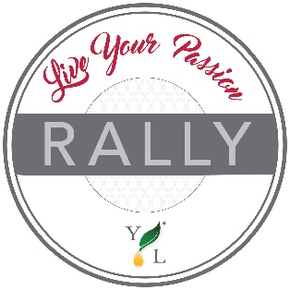
Event Agenda

Overview: Sample agenda for the Live Your Passion Rally
Time Topic Content Who
1. | 3 min. | Welcome | Welcome to the event!  - Set the tone of what to expect, generate excitement  - Introduce intro video to get started | HOST
2. | 1 min. | Corporate video segment | Intro Message – Jared Turner | Video
3. | 10 min. | Recognition | Recognize efforts of those in attendance  - Milestones/advancements/prize winners/retreats and qualification periods  - Corporate rep to recognize the council who put on the event (if applicable) | HOST
4. | 12 min. | Giveaways /  Icebreaker games | Product Giveaway’s | HOST
5. | 10 min. | Member experience | A few members share experiences/testimonials  Product focus (5 min.)  Business focus (5 min.) | HOST
6. | 5 min. | Message from corporate rep (if applicable) | Corporate Updates Slides 2-8 | REP or HOST
7. | 5 min. | Corporate video segment | Foundation Video | Video
8. | 3 min. | Corporate video segment | Seed to Seal: Science Pillar Video | Video
9. | 4 min. | Announcement | Infographic Video | Video
10. | 3 min. | Corporate video segment | YLC Video | Video
11. | 5 min. | PowerPoint Slides | YLC, Non GMO, Einkorn Slides | HOST
12. | 3 min. | Product Launch | Video | Video
13. | 8 min. | Product Launch | PowerPoint Slides | HOST
14. | 15 min. | Live training – message TBD by Host | Any product you’d like to train on/DIY Project | HOST
15. | 12 min. | Live training – message TBD by Host | Personal Development or Business Training | HOST
16. | 2 min. | PowerPoint | Enrollment 1.5 slides | HOST
17. | 2 min. | PowerPoint | SMS Slide | HOST
18. | 1 min. | Video | Teaser Video | Video
19. | 1 min. | Promotion | Promo Powerpoint Slide | HOST
20. | 5 min. | Close event/call to action | Take this content and event, build momentum with the promotion, and share the products!  Product Giveaway’s/Swag | HOST
TIME 120 min.

